OPEN SOURCEWEB PROGRAMMING
API Testing & Documentation
🔥 Bruno API Testing Collection 🔥
📊 13 Endpoints Tested

Project Overview
This document presents a comprehensive API testing suite developed for the Open Source Web Programming final project. Using Bruno, a modern API client, I have created and tested a complete REST API covering authentication, equipment management, booking operations, and customer data retrieval.

Technical Stack
• Testing Tool: Bruno API Client • Total Endpoints: 13 (11 primary + 2 negative test cases) • API Categories: Authentication, Equipment, Bookings, Customers • HTTP Methods: GET, POST, PUT, DELETE

Authentication Endpoints
The authentication system provides user registration and login functionality with secure token-based authentication.

POST /auth/register - Register New User
Creates a new user account in the system with email and password credentials.
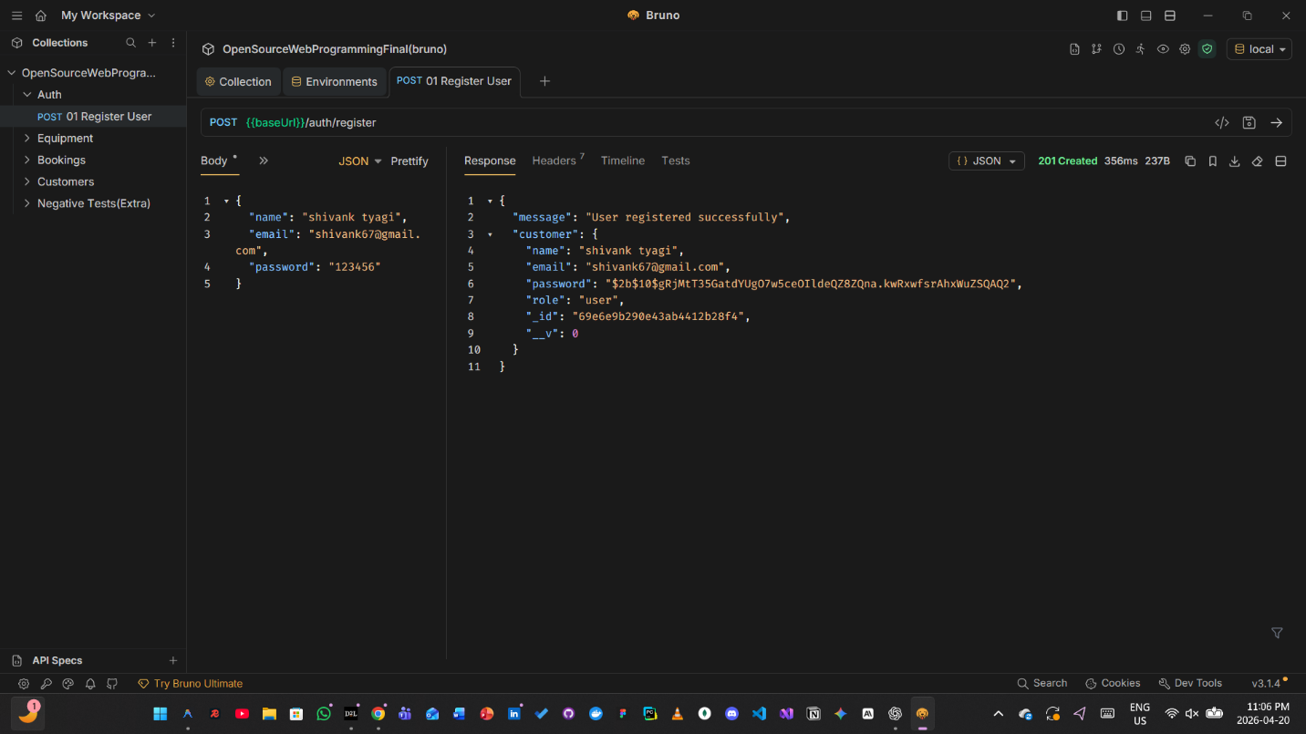

POST /auth/login - User Login
Authenticates existing users and returns an access token for subsequent API calls.
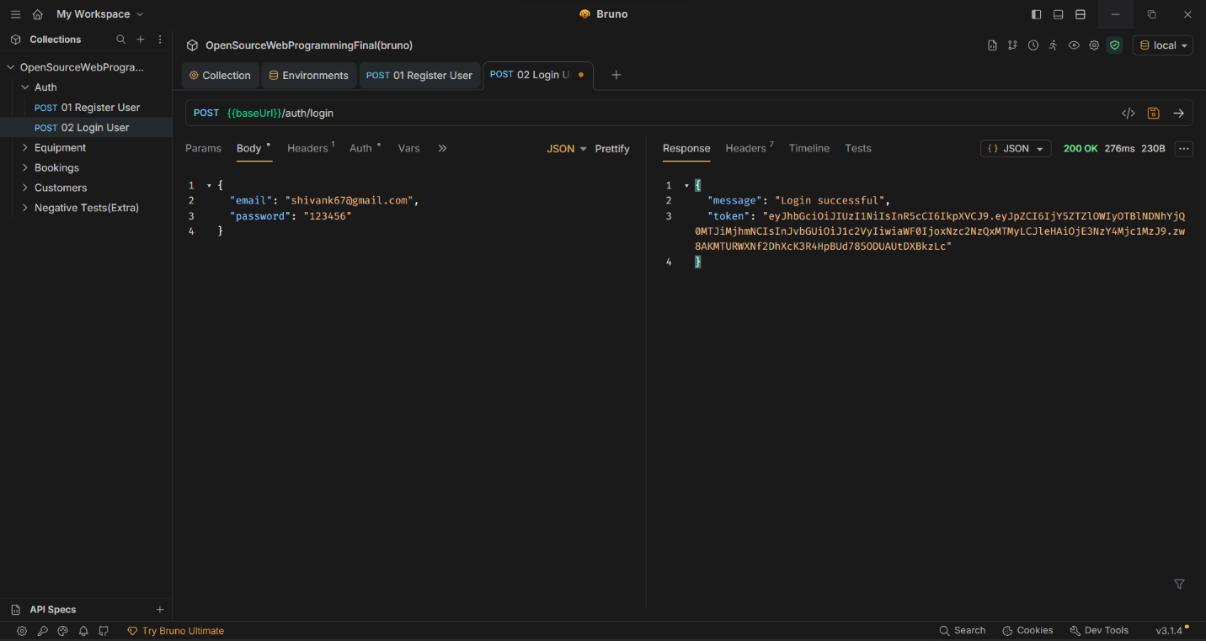

Equipment Management
Complete CRUD operations for managing equipment inventory, including listing, retrieval, creation, updates, and deletion.

GET /equipment - Retrieve All Equipment
Fetches a complete list of all equipment items available in the system.
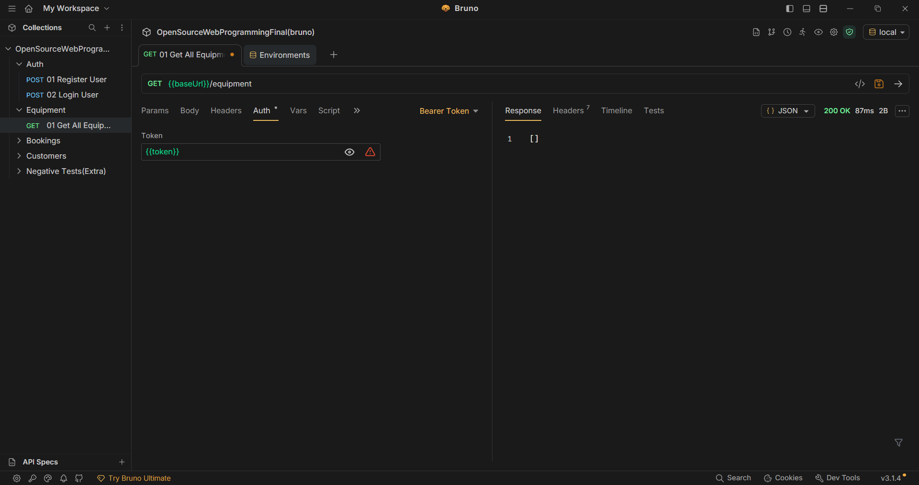

GET /equipment/:id - Get Equipment by ID
Retrieves detailed information about a specific equipment item using its unique identifier.
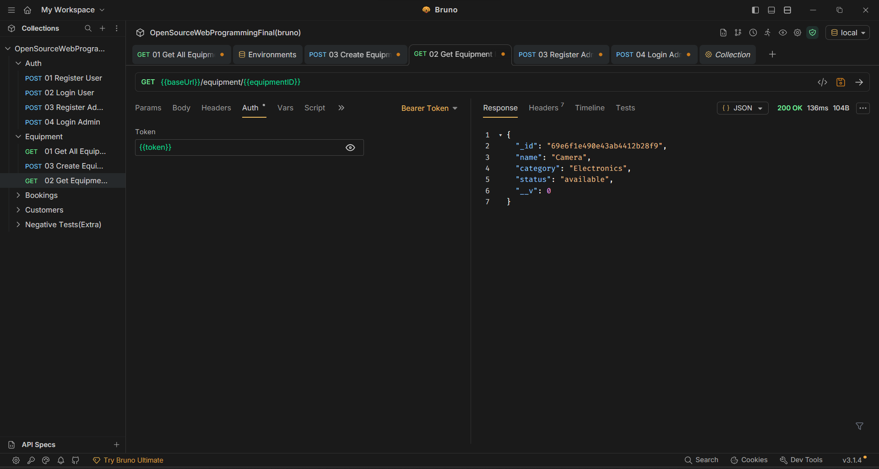

POST /equipment - Create New Equipment
Adds a new equipment item to the system inventory with all necessary details.
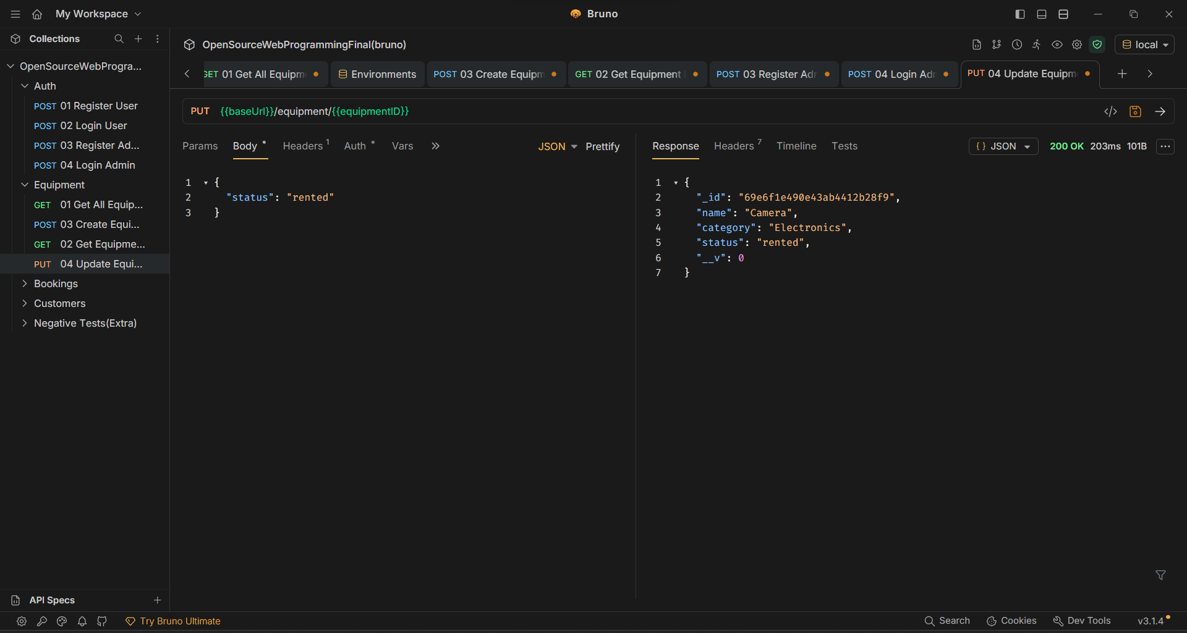

PUT /equipment/:id - Update Equipment
Modifies existing equipment information, allowing updates to any equipment attributes.
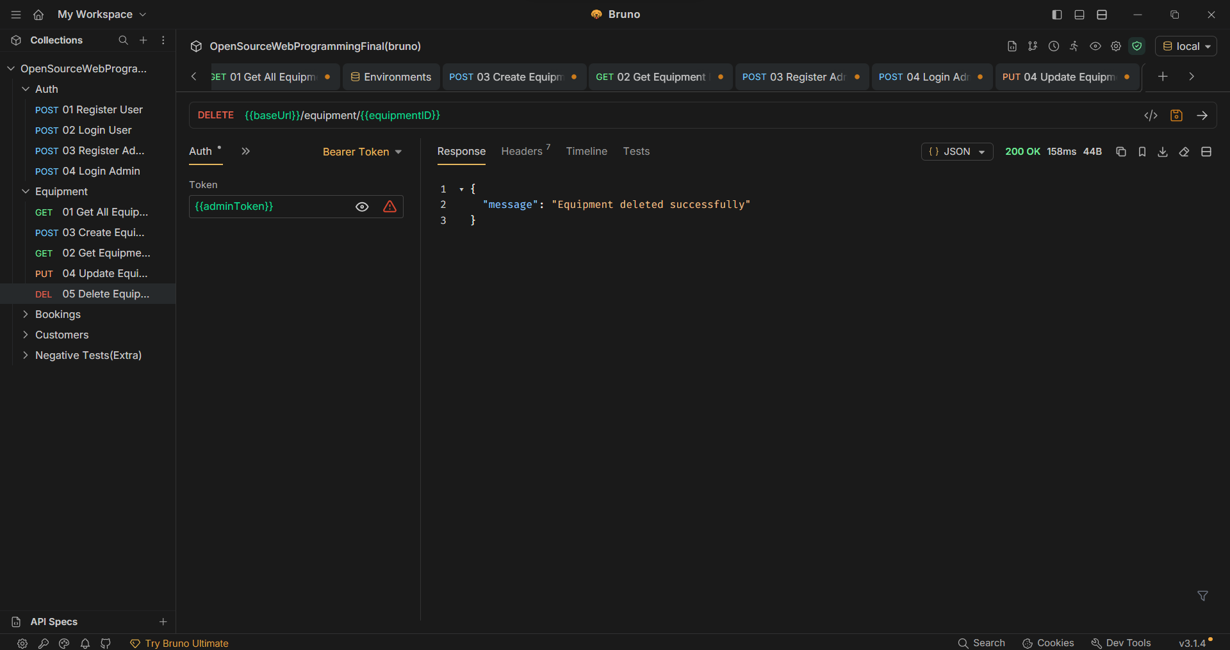

DELETE /equipment/:id - Delete Equipment
Removes an equipment item from the system permanently.
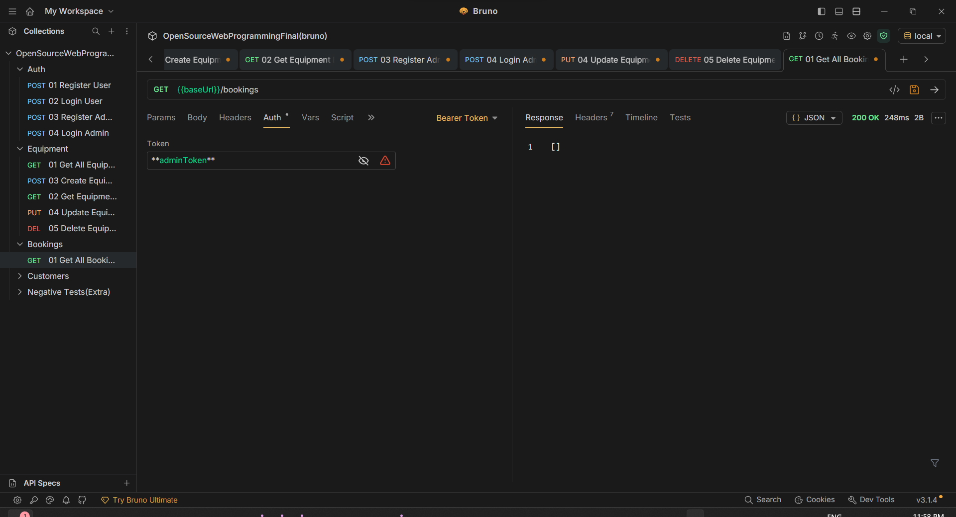

Booking Management
Full booking lifecycle management including creation, retrieval, updates, and cancellation of equipment reservations.

GET /bookings - Retrieve All Bookings
Returns a comprehensive list of all booking records in the system.
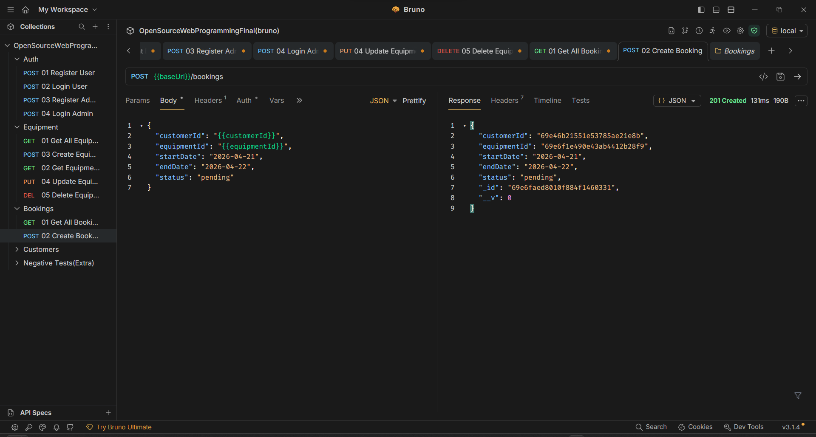

POST /bookings - Create New Booking
Creates a new booking reservation linking customers with equipment for specific date ranges.
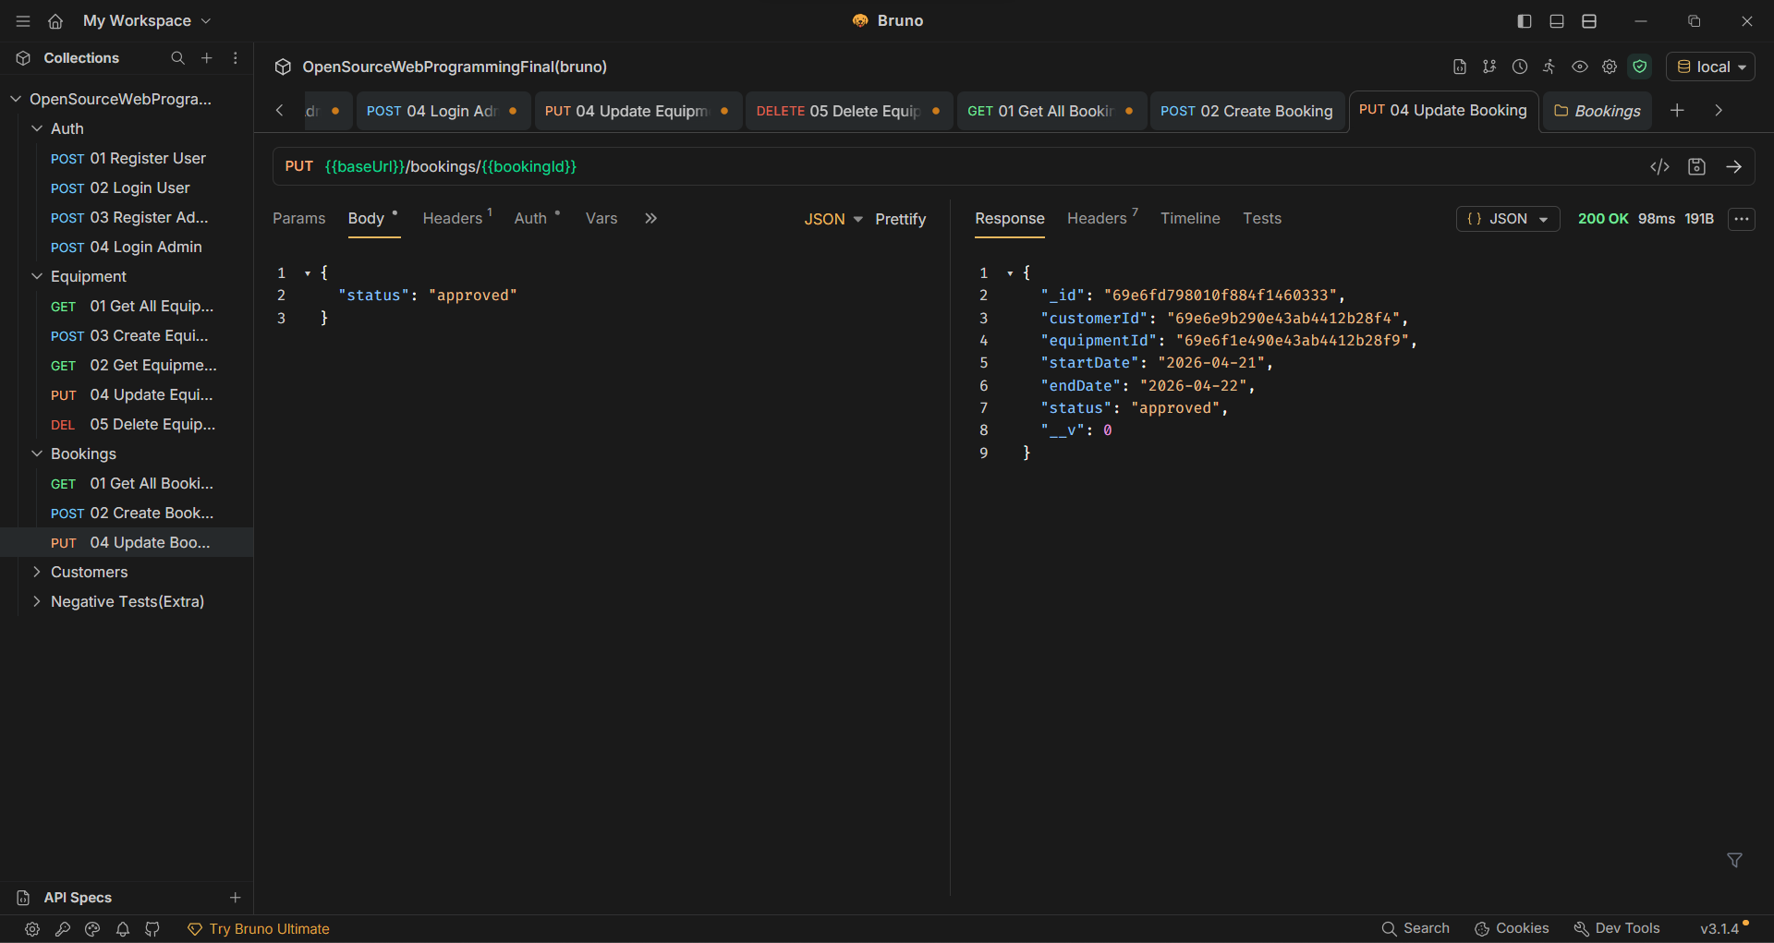

PUT /bookings/:id - Update Booking
Modifies existing booking details such as dates, equipment, or status.
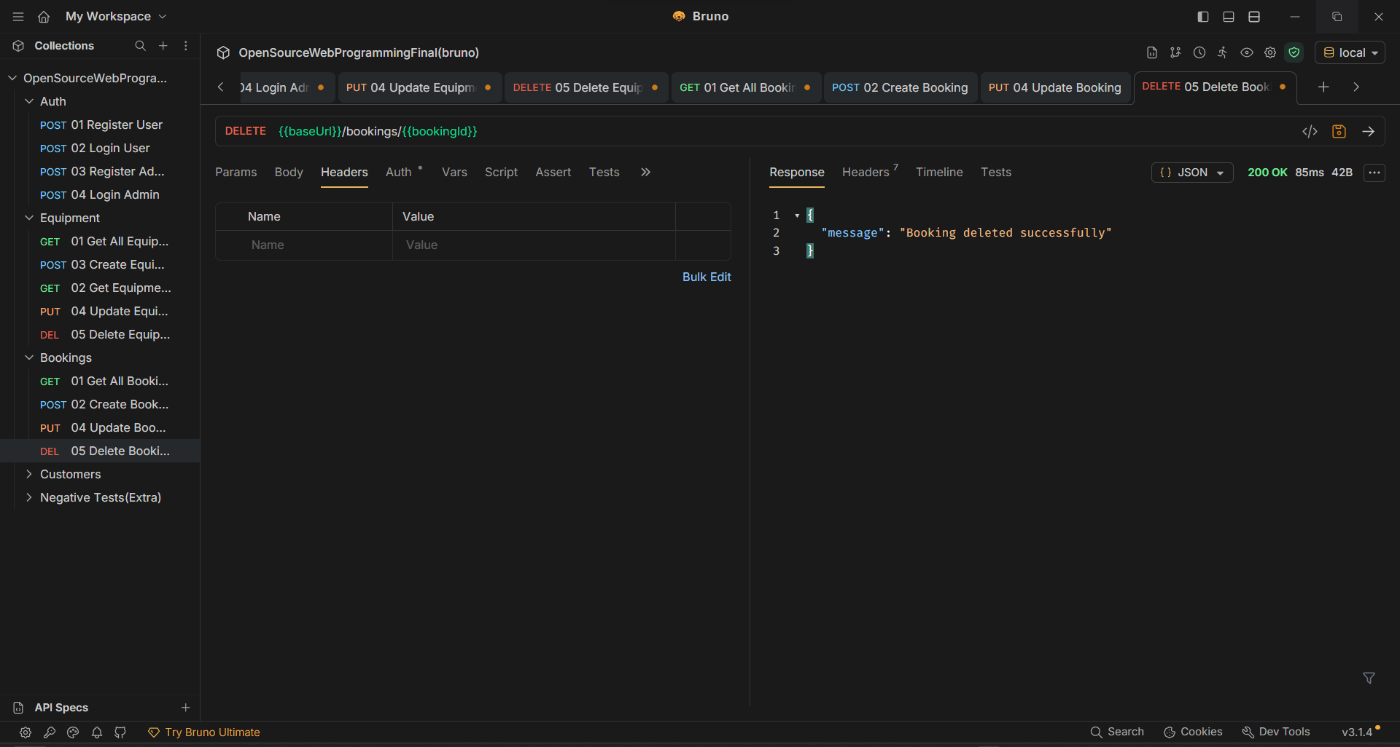

DELETE /bookings/:id - Cancel Booking
Cancels and removes a booking from the system.
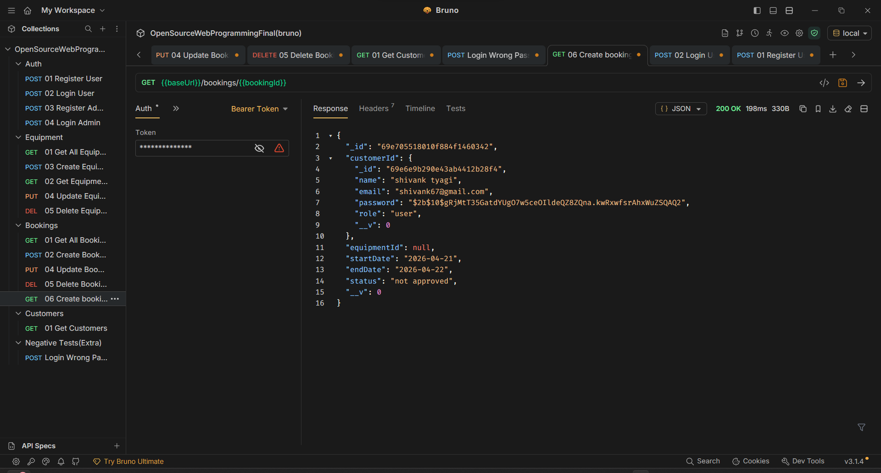

GET /bookings/:id - Get Booking Details
Retrieves detailed information about a specific booking using its unique identifier.
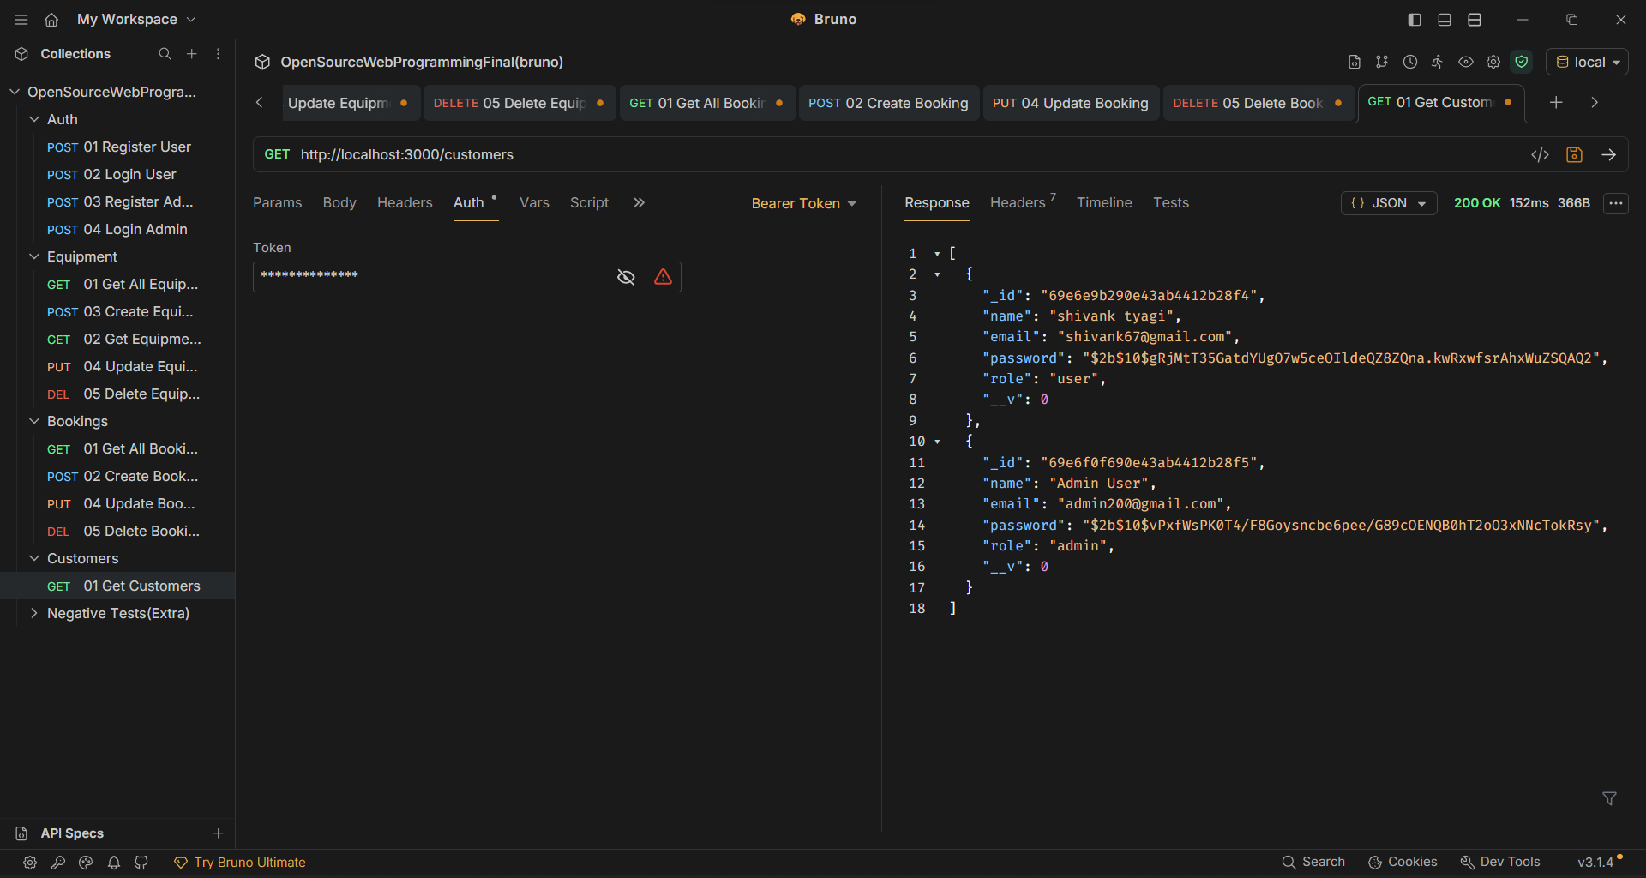

Customer Management
Customer data retrieval for viewing registered users in the system.

GET /customers - Retrieve All Customers
Returns a list of all registered customers with their account information.


Negative Test Cases
Additional test cases designed to validate error handling and edge cases in the API, ensuring robust and reliable system behavior.

Login with Wrong Password
Tests authentication error handling when incorrect credentials are provided, ensuring proper security measures.
Expected Result: 401 Unauthorized with appropriate error message

Create Booking with Invalid Data
Validates data integrity checks and validation rules when attempting to create bookings with malformed or invalid input.
Expected Result: 400 Bad Request with validation error details

Testing Summary

Test Coverage
• Total Endpoints Tested: 13 • Authentication: 2 endpoints • Equipment Operations: 5 endpoints (full CRUD) • Booking Operations: 5 endpoints (full CRUD) • Customer Operations: 1 endpoint • Negative Test Cases: 2 scenarios

Key Achievements
✓ Complete REST API implementation ✓ Comprehensive CRUD operations for all resources ✓ Secure authentication system ✓ Robust error handling validated through negative tests ✓ All endpoints tested and documented

Tools & Technologies
This project demonstrates proficiency in modern API development and testing practices using Bruno, a powerful open-source API client that provides a clean, organized approach to API testing and documentation.

Conclusion
This comprehensive API testing suite successfully validates all core functionalities of the equipment booking system, ensuring reliable and secure operations across authentication, resource management, and data retrieval endpoints.

